

How to Locate CTE Revenue Information for Districts

CTE Aid (what the State Kicks in) + CTE Levy (District Taxes for) = Total Revenue

https://public.education.mn.gov/MDEAnalytics/DataTopic.jsp?TOPICID=9

Report for Individual Independent School Districts
(includes Aid and Levy)

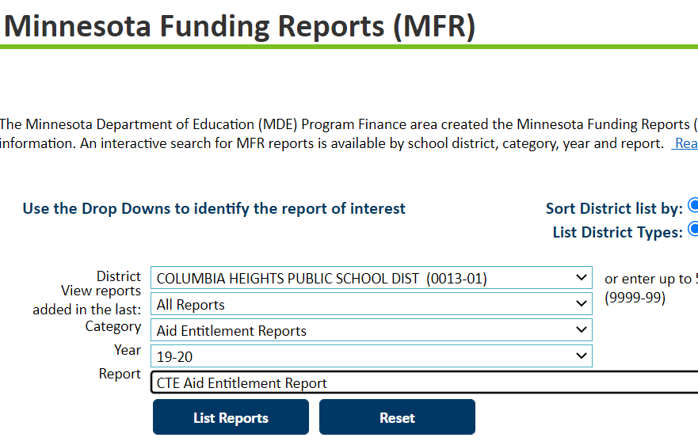

Scroll down for report interpretation example.

Sample Report: See below for what the #’s mean. 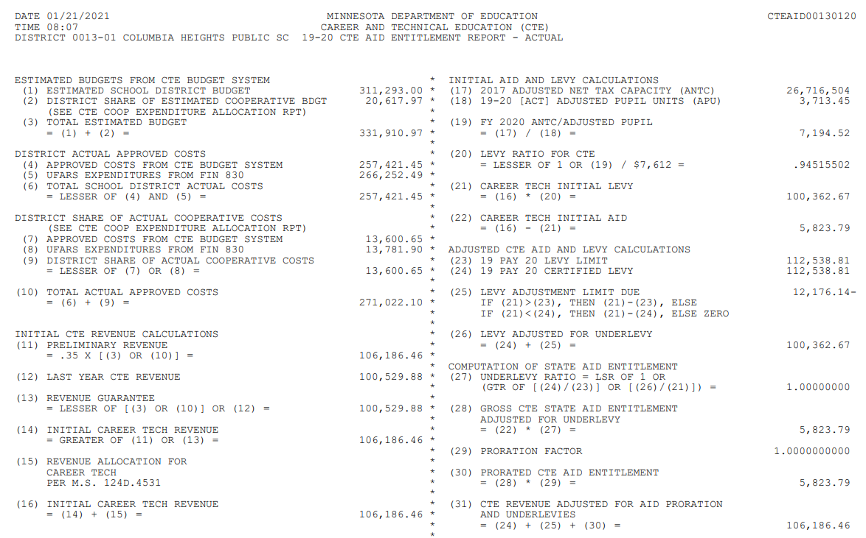
What the #’s mean:
Line 3: Estimated Budget (entered into CTE Budget system fall of SY prior)
Line 4: District Actual Reported Spent (entered into CTE Budget system summer after SY ends)
Line 5: District Reported to MDE Finance via UFARS
Line 31: Revenue Received by District

